AN AI ATTENDANCE SYSYTEM

STUNDENT LOGIN PAGE –

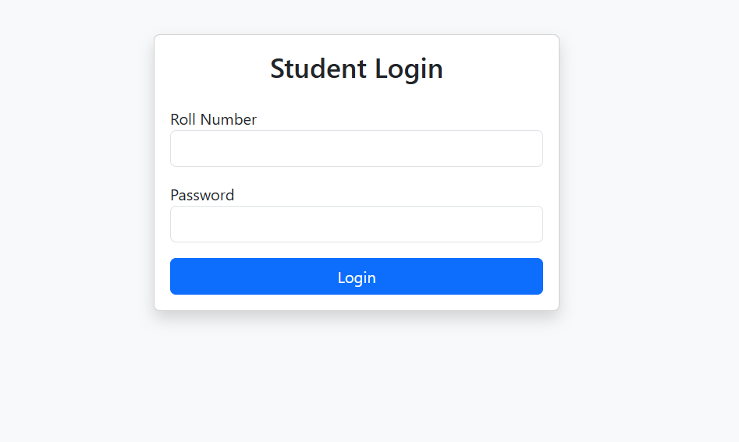

STUDENT DASHBOARD –

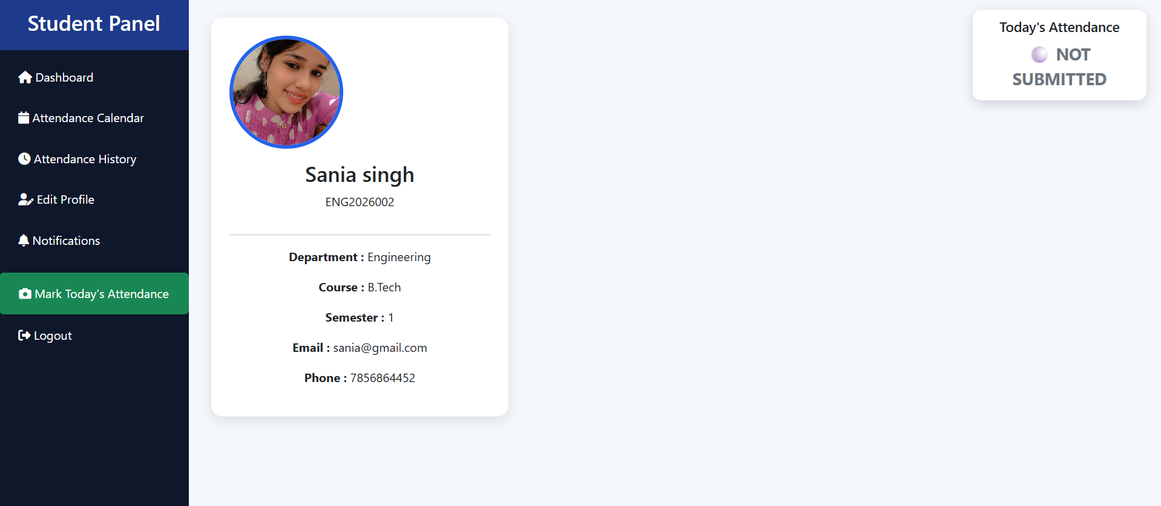

STUDENT CALENDER –

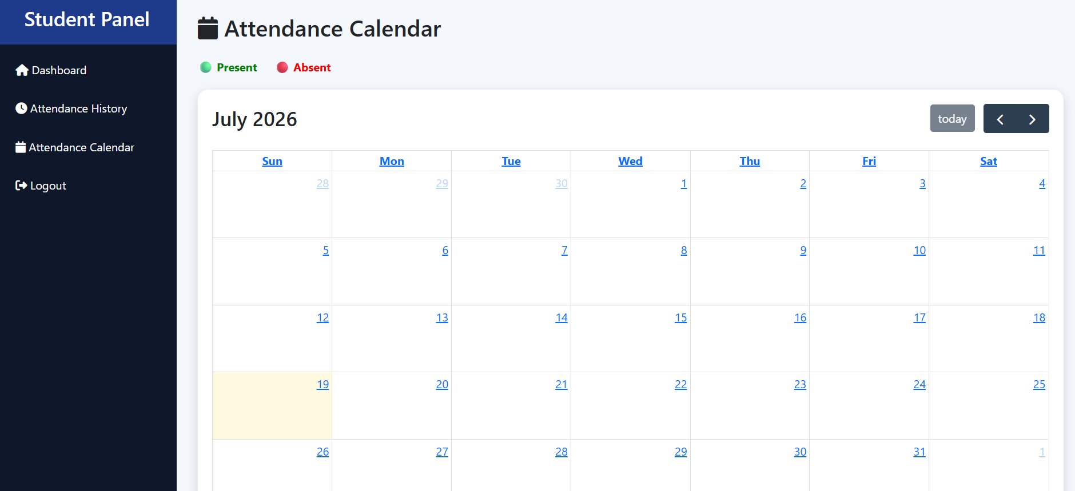

MARK ATTENDANCE ONLINE VIA CAMERA-

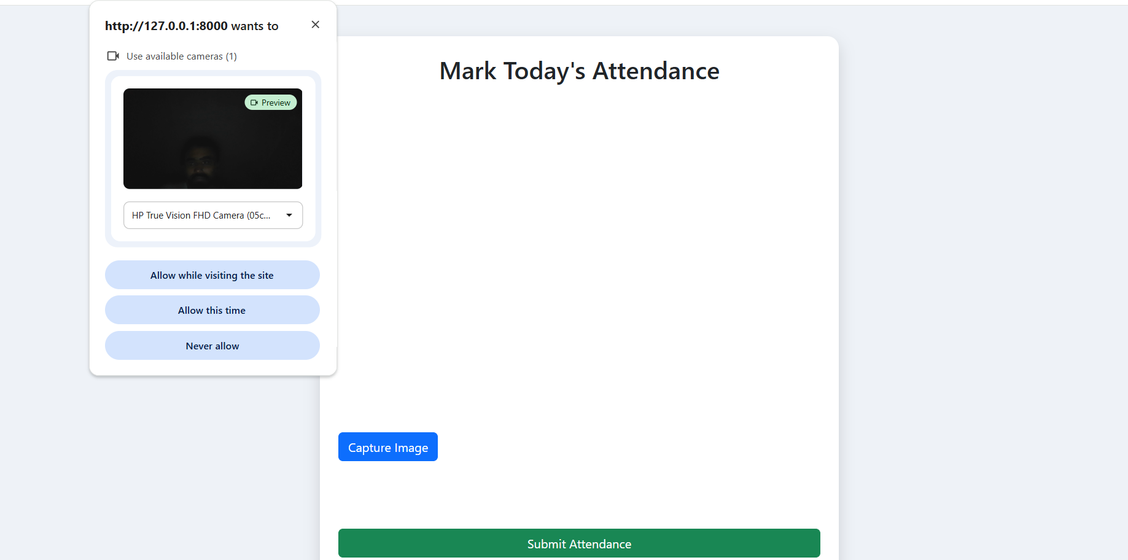

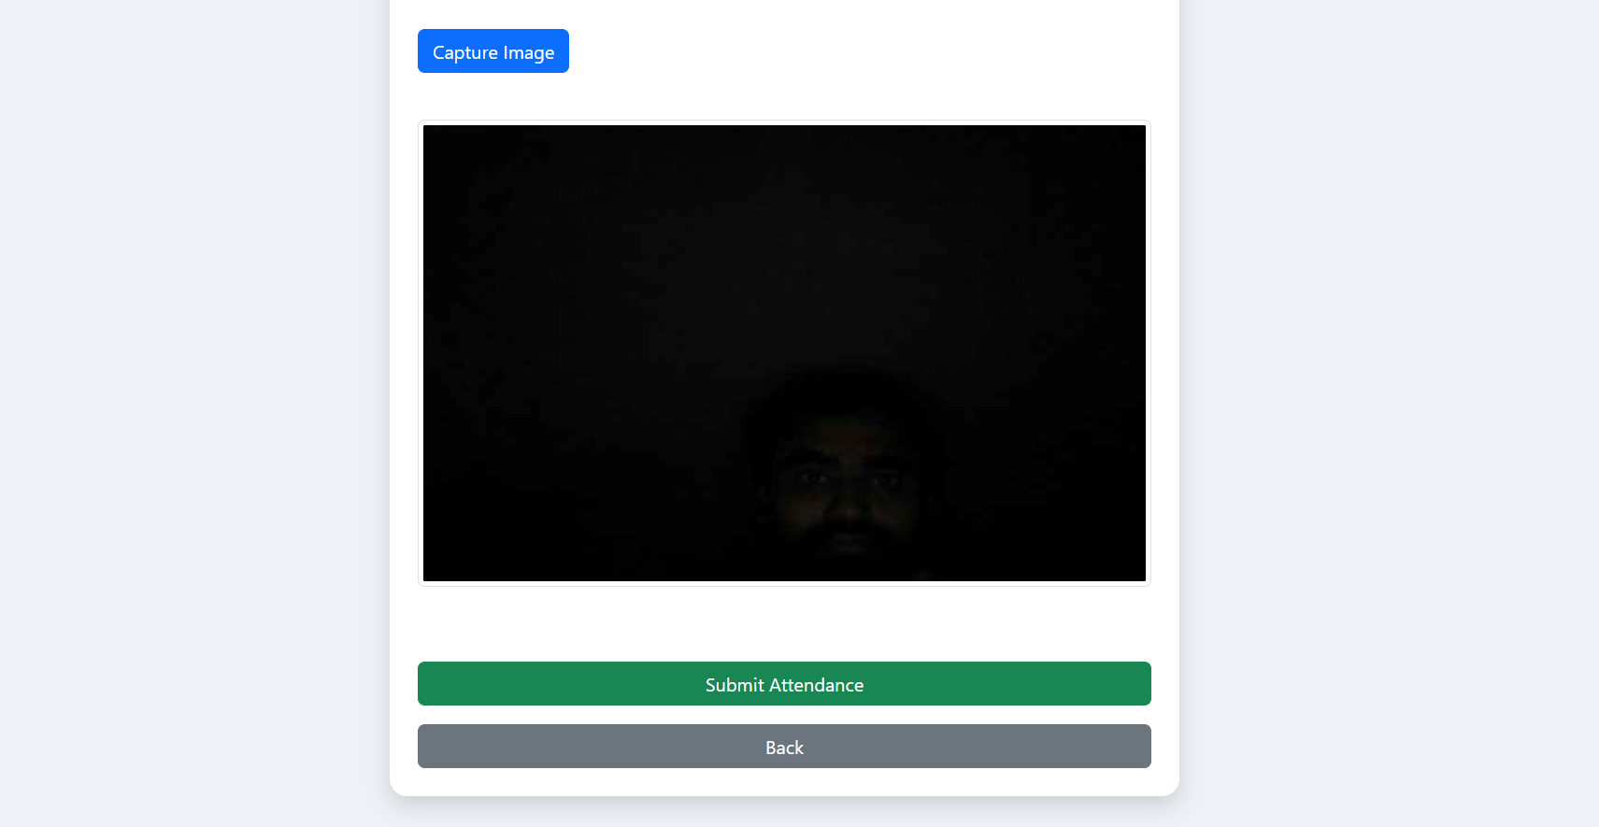
ATTENDANCE TYPE –
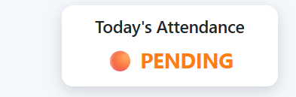
EDIT PROFILE FOR STUDENT –
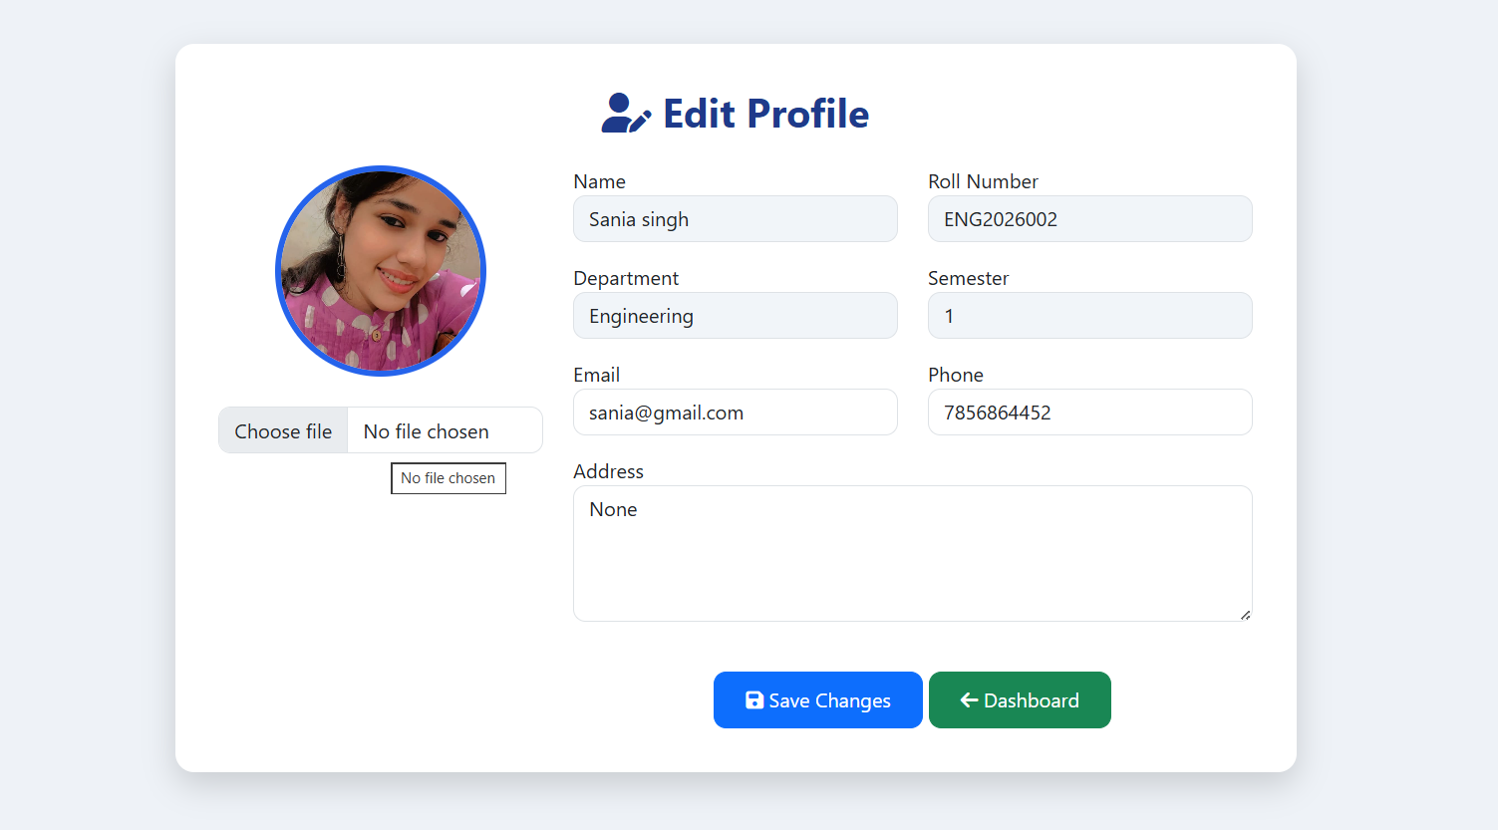

ADMIN DASHBOARD –

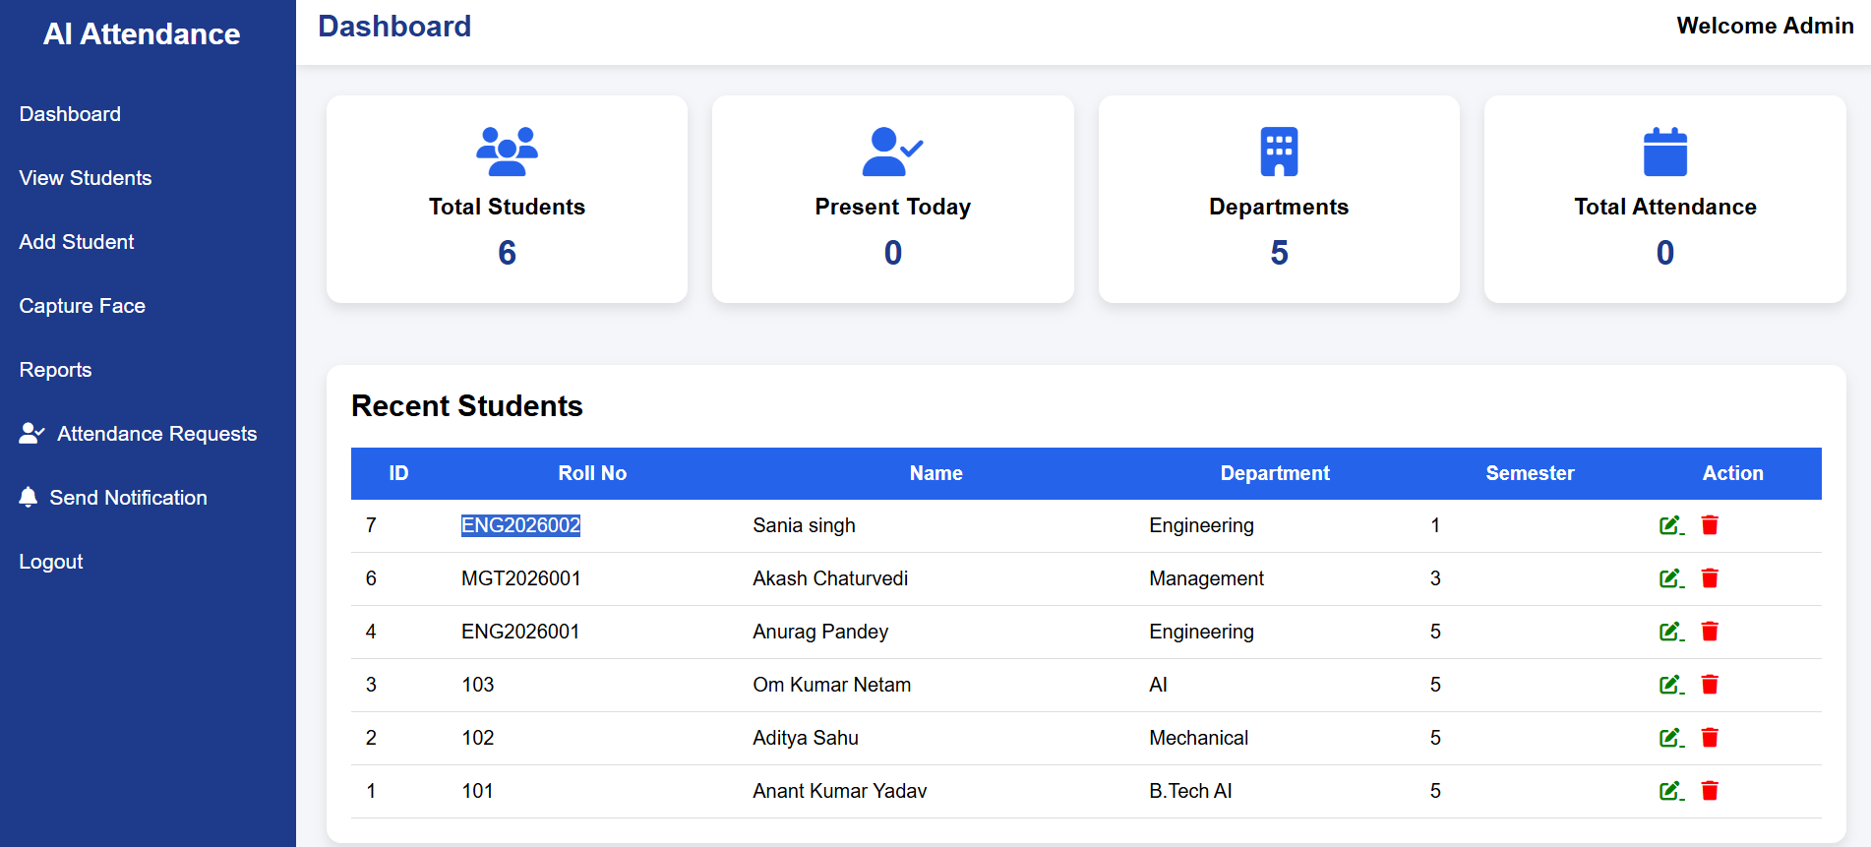
ATTENDANCE PANNEL –
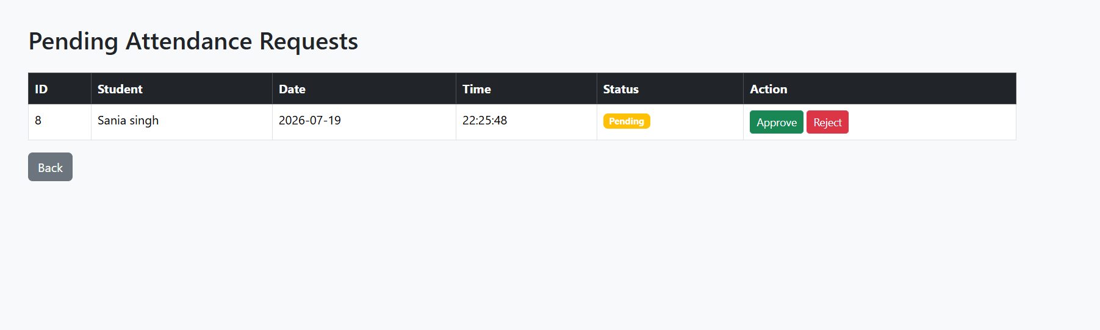
VIEW STUDENT –
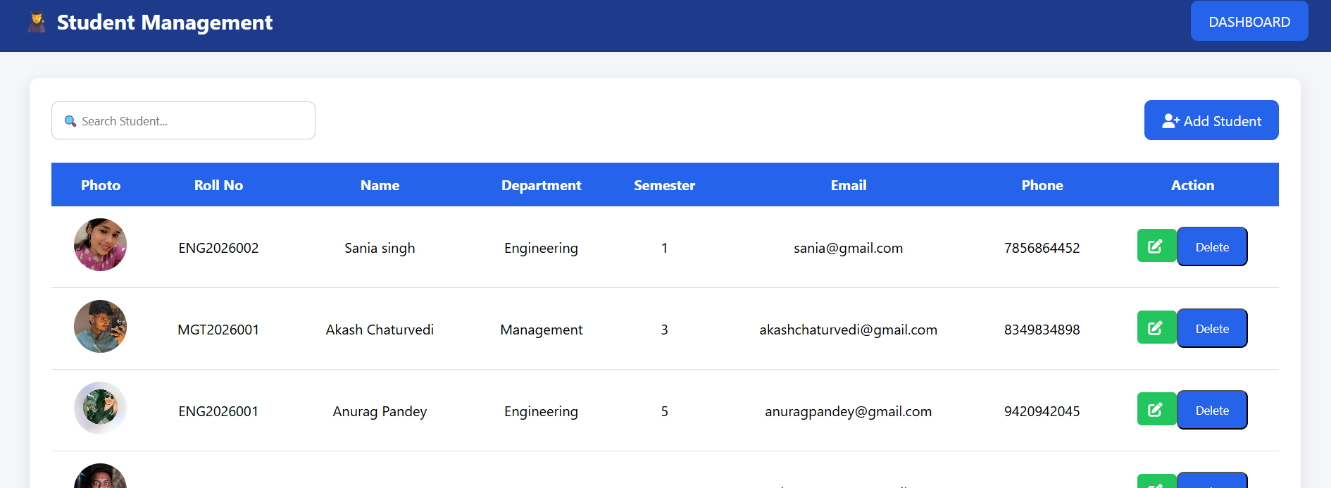
ADD STUDENT – 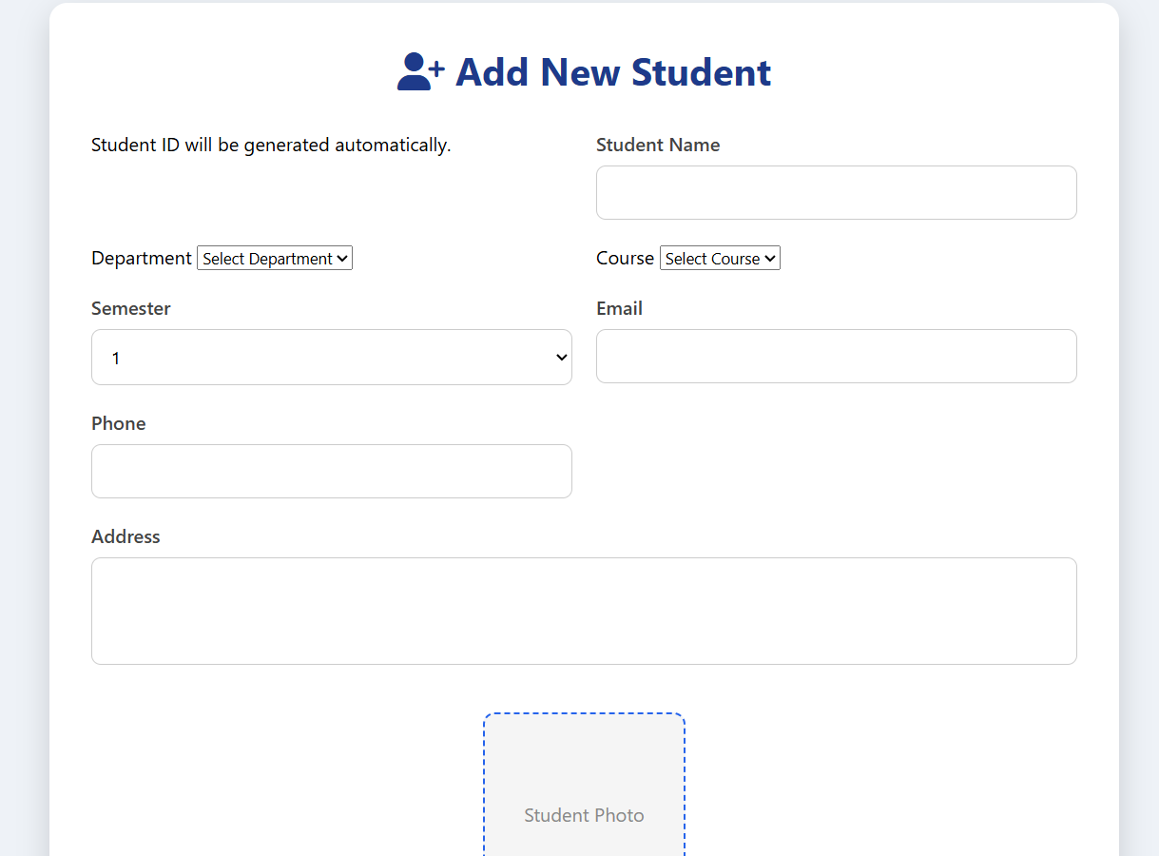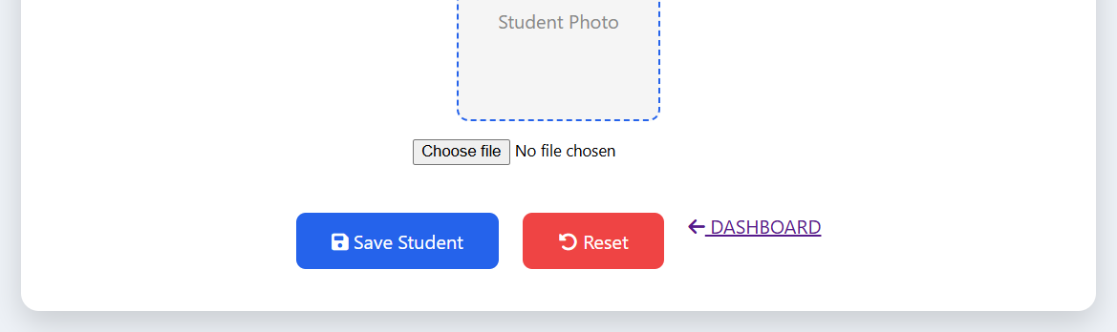
SEND NOTIFICATION –
